Requirement Document

version 0.0.1

Chaojie Wang

**Overview**

This is an Internet of Things project, and it is called Wolfie Home. Basic idea is to connect physical devices to the Internet. The house owner is able to monitor the status of the devices and control these devices in a website. This document is written for new members who are new to the project, so that they can get rough sense of what is it about. Old members can use this as a guideline.

**Physical Devices**

Many things can be monitored and controlled in a house, such as air conditioner, cooking machines, light bulbs and so on. But, many of these devices are not programmable. So connecting them into the Internet is difficult. So, for now, we will use following “devices”: LEDs, temperature sensors.

For example, a house could be:

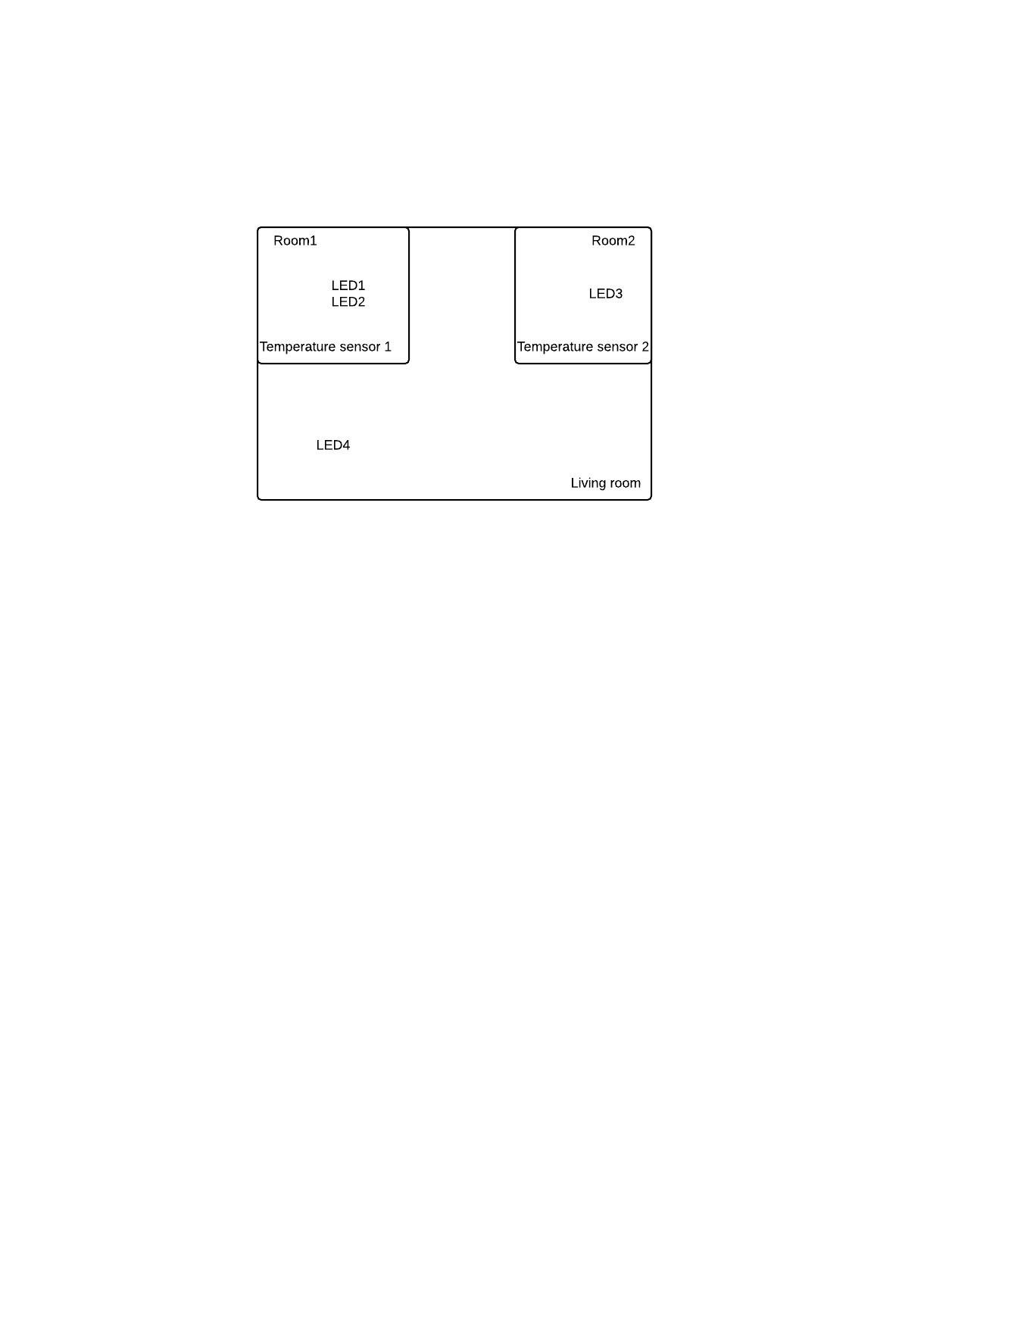

**User Interface**

Users can interact with the devices with a website. The website provides two functionalities: monitoring and controlling. The user need to log in, in order to use these functionalities.

Users can monitor status of physical devices. For example, the room temperature, and status of LEDs. Users can control some physical devices, for example turning off and turning on LEDs.

Example layout of the website:

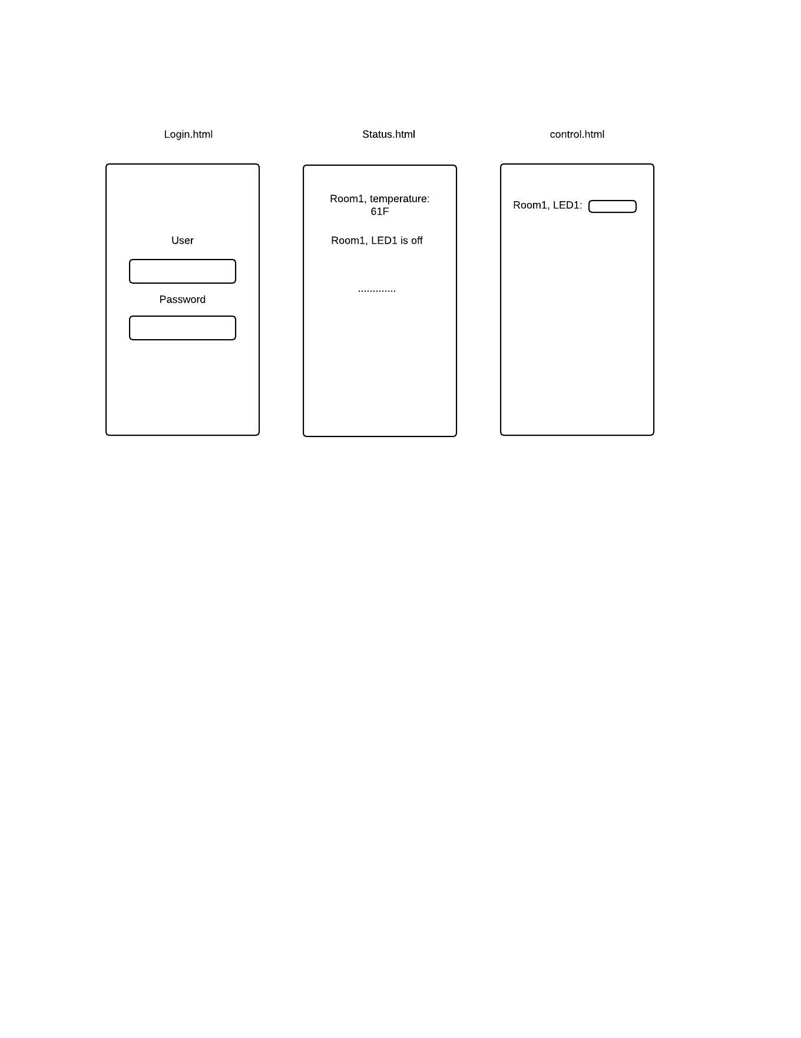

**Additional Note**

The specific implementation is not specified here. This is just a general concept. It is straightforward and easy right now. After this is done. We can add more requirements, for example AI, expert system and so on.